SHOBNALL PRIMARY SCHOOL

NEWSLETTER EASTER 2007

Dear Parents

We have pleasure in presenting this terms newsletter, which brings you the latest information and the range of activities, which have been happening within School during the second half of the spring term.

NURSERY

This half term our topics have been ‘Nursery Rhymes’, ‘Pets’ ‘Spring’ and ‘Easter Celebrations’.

The Nursery Rhyme corner proved very popular. The children were able to access the cassette player and sing along with Humpty Dumpty and other favourite rhymes.

Mrs Keen, kindly knitted a very handsome Humpty who proudly sits on, or occasionally falls off, the wall that the children made. Thank you Mrs Keene, we will treasure him.

At present the role play area has been transformed into a VET’s corner. The children have brought in their soft toy pets to explore. We did, however, have a surprise visitor, ‘Pip’ the
two year old tortoise, Georgie thought it would be a great treat to bring in her real live pet and it certainly was. We learnt how to gently hold and care for a tortoise. Thank you to Georgie and her mum.

Mrs Lakin kindly brought in her lovely West Highland Terrier ‘Rosie’. The children thought she was delightful and learnt about how to care for a dog. Many thanks to Mrs Lakin.
Miss O’Dell’s ‘Pablo’, a lop eared rabbit, made his second appearance at Shobnall. He was hugely popular and the children were extremely good. They were able to observe him during the morning session and learnt how to care for a rabbit. Thank you Miss O’Dell for bringing Pablo in.

Our final ‘pet’ visitor was ‘Kovu’ the hamster, he belongs to Mrs Curran’s daughter, Holly. He was very active and the children were delighted to see him exercise in his ball – what a clever hamster! Thank you Holly, we really enjoyed Koru being in the Nursery. Mrs Marston kindly brought in some frogspawn from her pond. The children and grown ups alike have been fascinated with the daily developments!
We are now busy with our ‘spring’ topic and looking forward to Easter.

Thank you for your continued support and kindness. Mrs Short, Mrs Curran, Mrs Marston.

NEWS FROM RECEPTION CLASS

This term started off with a ‘first’ for everyone. The children contributed, for the first time, to lead as assembly. Each child thought carefully about how they show kindness and share with other people. During the assembly the children showed confidence to individually verbalise their idea to the whole school.

The topic this term has been ‘pets’. Children have been interested and motivated to develop their learning by bringing photographs to school sharing their own thoughts about caring for pets and using the class theme area to role play scenario’s for events at the vet’s. Mrs Bickley has been really pleased with how the children have worked together to make the ‘vet corner’ a great learning resource. ‘Pets’ have been given a multitude of ‘medical examinations’ with countless occasions when a ‘bandaged point’ was the order of the day! Well done children …………………. Learning was certainly fun!

Mrs Bickley would like to thank ‘Rosie the Dog’, the Lakin family pet, and ‘Pablo the Rabbit’ Miss O’Dell’s house rabbit, for giving the children opportunities to observe and talk about aspects of specific pet needs from first hand experiences.

Year 1 have enjoyed making their own non-fiction books all about materials and their uses. This topic links closely to our science work this term.

Reverend Paul Farthing continues to visit school approximately once a term to deliver our collective worship based upon the weeks themes.

Each class has carried out a class ‘assembly’ again based upon our weekly theme and using our recently acquired assembly books. I have continued to be very impressed with the children’s acting skills and their confident public speaking.

Healthy Schools
At the start of this term Teresa McCullagh from the Staffordshire Healthy Schools Team visited school to liaise with the PHSE co-ordinator in order to review the Healthy Schools Award audit. She gave very positive feedback and was ‘impressed with our schools progress and contribution to working towards Healthy Schools Status’. There are now a few ‘jobs’ to be completed which should lead to us achieving our status, hopefully by the Summer.

Safety Officer Hall has delivered part of the PHSE curriculum to the following classes:

Year 6 – crime and consequences
Year 5 – drug awareness
Year 3 – using sense and staying safe.
As usual the children have enjoyed this sessions and discussion with the children show that they are increasingly aware of personal safety issues.

Gary Dennis is doing a fantastic job leading the ‘Starting Out’ road safety program for Year 1. With his team of willing volunteers, Mr Dennis takes the children each Monday afternoon to enhance their road safety and road awareness. Thank you to the team for all their help.

Year 2 children have been very busy this term. They all enjoyed taking part in the Beatrix Potter Performance and all performed brilliantly. In Literacy we have been writing letters and finding out about the features of explanation texts. The children have made some lovely stained glass windows concentrating on the use of colour and pattern in their designs. During Numeracy this term we have been practicing using our number lines for addition and subtraction. We have also been looking at 2D and 3D shapes and their properties. Well done to everyone for trying so hard with their handwriting. A great term Year 2 well done!

SWIMMING

Year 2 swimmers have tried very, very hard this term and are very close to achieving their ‘Goldfish’ and ‘Turtle’ awards next term. Nearly all of the class are now confident swimmers and lots of children are happily swimming without swimming aids. Swimming will commence again on the 24th April 2007 and finish for Year 2 on 22nd May 2007. After half-term Year 6 will be given the opportunity to swim.

ART IN SCHOOL

We are always proud of the Art produced in school, and Years 2 and 4 have enjoyed receiving support from Mrs Taylor, our chair of Governors. Mrs Taylor has extensive teaching experience and is also a keen artist! Come and view the stained glass windows in the Year 2 classroom!

You might also like to take a look at the notice board in the corridor adjacent to the computer suite, at the display created for us by Robert King, who has been helping in Year 3 since September. Thank you Robert for this stimulating display of the children’s work which shows the progression of writing skills through Key Stage 2.

BEATRIX POTTER

I would just like to say a big ‘well done’ to each and every single child for their wonderful performance at the Brewhouse in February. Not only did every child sing and perform to the highest standard but they were so professional during the rehearsals, and superbly behaved. I am sure that they will all treasure every minute of the performance forever. We were very proud to see their achievements displayed in the Burton Mail three weeks ago!! Thank you also to Stephanie Parrott for her continued hard work at our school.

Year 2 Dance Festival
On Friday 23rd March, children from Year 2 were invited to a ‘Dance Festival’ at Paget High School. Throughout the afternoon, the children were taught different movements and steps from a variety of dance styles including Line dancing, Street and Bhangra dancing. We all had a great time learning dances and listening to music from a variety of cultures.

Year 3 have had a very busy half-term. In Literacy we have been improving our skills for story, instructional and letter writing. We are trying to use different sentence openings, connectives, adverbs, adjectives and similies to improve our writing.

In Science we have been developing our investigation skills in order to find out what plants need to grow. The children have shown a super understanding of what is needed to make it a fair test!

In the DT Topic this term the children have used hacksaws and wood to create a photo frame! I hope the parents like their Easter Gift.

Thank you to everyone who has wished me well for the forthcoming months. I hope you all have a wonderful Easter Holiday.

Mrs Taylor.

VISIT FROM BT
SPEAKING AND LISTENING SKILLS

Year 1 and Year 3 enjoyed a wonderful theatre visits from BT! It made us all realise how important listening to instructions is and that we need to communicate so that other people can understand us!

Talk Dogs - 8 Top Tips
- Clear your mind
- Take turns
- Ask Questions
- Respect
- Give Details
- Eye contact
- Be interesting
- Listen for the important bits

Thank you to BT and Mrs Coombs for organizing this visit to Shobnall School.

Football

The Dove Valley Football League came to a finale this half term and going into the final stages of the season, the team was in a very strong position after convincing wins earlier in the year.
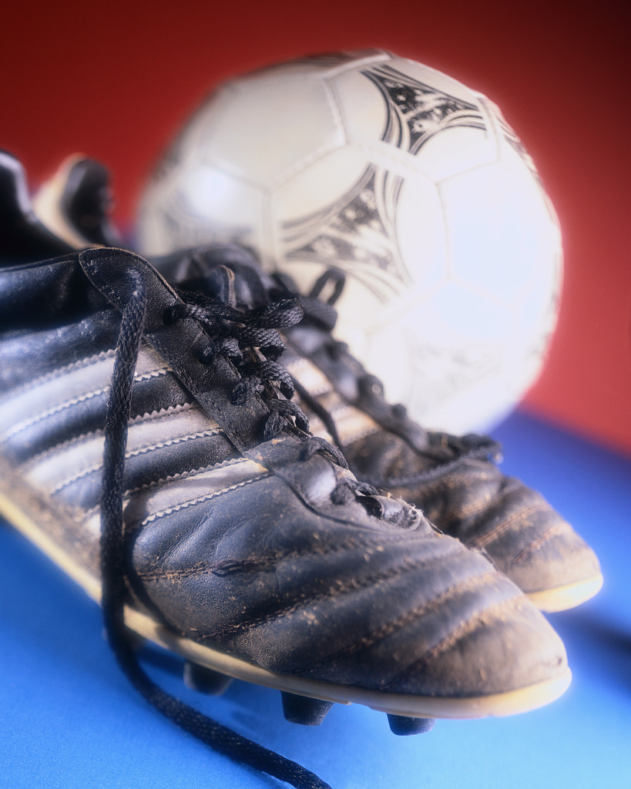

Things became even more encouraging with the addition of a new school kit which was worn for the first time this half term. However, with the arrival of the new school kit came our slump in form and amazingly we failed to win any of our last 5 remaining matches although admittedly it was against tough opposition from Rykneld (twice) and William Shrewsbury amongst others.

Nevertheless, it has been an exciting football season yet again at Shobnall and lets’ hope that our fortune can change with our new kit in the forthcoming hockey, athletics and rugby fixtures in the coming weeks.

PFA Bingo

The PFA at Shobnall school have been extremely busy and keen to continue to raise their profile within and around the school community.
This half term saw the first Easter Bingo evening under the guidance of our new PFA committee. What a successful evening. It was great to see so many of you here, attending and supporting the school yet again and I am sure most of you went away feeling that it was a worthwhile venture and fun evening. Hopefully you were not too disappointed if you failed to scoop one of the many prizes and I am sure we can rely on your support for future PFA events. One date for your diary is the school Summer Fayre to be held on Saturday, 23rd June 2007.

YEAR 5
Year 5 Visit from Mr Hall

Mr Hall visited Year 5 to talk about drug awareness. Children were made aware of the possible dangers and hazards they could be faced with when playing out with their friends.

Dads and Lads

Children from Year 3 and 4 are currently taking part in the ‘Dads and Lads’ scheme. Each week they take home a reading book and a piece of sports equipment with an activity card. The boys enjoy taking part in the scheme and look forward to their next challenge each week.

EASTER BONNET PARADE

The Shobnall children were sent on a mission last week to participate in our Easter ‘Top Hat’ or ‘Bonnet’ competition for the Grand Easter Bonnet parade. There were two winners from each class from Nursery through to Reception and each class received an Easter egg prize. The winners were:

Nursery: Louis & Grace
Reception: Kalum & Victoria
Year 1 Keenan & Hannah
Year 2 Mark H & Darcey
Year 3 George & Hannah
Year 4 Jack & Charlotte
Year 5 Jack & Sophie
Year 6 Liam & Maddy

CLUBS NEWS
ICT/MEDIA CLUB

Children in Year 3 and 4 have had a great time in ICT club this term. They have been very busy producing their own newsletter for the children in the school. The children have used publisher to create two separate letters for KS1 and KS2.

Well done to everyone involved in the ICT club, you have worked very hard.

SCHOOL WEBSITE

The school website has been maintained this term, with pictures of the children’s work being displayed for each class. Also dates of forthcoming events can be found.

TESCO VOUCHERS

Tesco’s are again providing vouchers for schools and we will be collecting them again this year. Your support is greatly appreciated and a box can be found in the entrance foyer, should you wish to contribute.

It was wonderful to see so many children at the PFA disco enjoying themselves and ‘getting into the groove’ with their dancing. The children were very well behaved and altogether the PFA raised a grand total of £322! Well done and thank you to all the additional helpers – without you, these events would not be able to take place.

BOOK FAIR
The book fair has been an amazing success yet again. We had a fantastic response to the fair, with many children purchasing new and exciting books. Over the four days we purchased over £1,000’s worth of books. This staggering total earned the school £397.00 in commission. Each class teacher has selected new books for their class that are now available for the children to borrow.

To add to our reading celebrations we held a book character day. Each child was invited to dress up as a character from a book, the response was phenomenal. All of the children made a supper effort with their costumes and I would like to extend a huge thank you to all of the parents who have contributed to the making of these costumes.

The winning children from each class were awarded vouchers to spend at the book fair. The winners were:

Nursery - Lewis Emmerson
Reception - Samuel Smith
Year 1 - Hannah Stockman
Year 2 - Darcey Moore
Year 3 - Chloe Gooding
Year 4 - Charlotte Moore
Year 5 - Holly Phipp
Year 6 - Georgia Dennis

STUDENTS IN SCHOOL

Our school continues to support local students from Burton College.

Reception - Charlotte Woodhouse
Reception - Amy Rowley
Year 1 - Zoe Dunbar
Year 1- Sarah Gould

NATIONAL TESTS (SAT’S)
MONDAY 14TH TO FRIDAY 18TH MAY 2007

Please note that these are the dates in which children from Year 6 undertake National Tests. These dates are non-negotiable and are set by the Government. Children who are not at school during this time are not allowed to take tests at a later date and will therefore not be given a level for their Primary School achievements. Would parents please therefore ensure that children attend school each day throughout this week.

In addition all children throughout school will also be completing their end of year tests throughout this week. As notified at the beginning of the year Parents are requested not to take their annual holiday during this week.

SAT’S MEETING FOR PARENTS

There will be a forthcoming SAT’s meeting for parents of Year 2 children on 26th April, 2007 in the Year 2 classroom. This will enlighten parents of the procedures delivered during May, to see examples of the papers given and to stop them from worrying!!!

JOHN TAYLOR HIGH SCHOOL PARTNERSHIP SCHEME

This term Mrs Bickley has attended the Partnership meeting which was led by the LEA science advisor Wendy Precious. The focus for the meeting was aspects of the topic ‘electricity’. The Partnership also provides activities to enhance children’s learning at Shobnall.

JTHS staff have been into Year 6 class to work with the children. On Monday 19th March Year 6 children enjoyed an afternoon investigating light effects through a variety of different materials. To explain, analyse and present their findings the children used computer equipment with data logging capabilities. On Thursday 22nd March JTHS staff organized a heart dissection demonstration which gave the Year 6 children lots of opportunity to revise aspects of the heart and circulatory system in preparation for the forthcoming SAT’s.

Wednesday 21st March children from Year 4, 5 and 6 were treated to a ‘show extraordinaire’ – Mr Beetle’s Watery Adventure’ came to Shobnall! ‘Mr Beetle’ used web cam technology to present a plethora of experiments linked to water concepts. It was an enjoyable morning and provided a wealth of knowledge about the ‘physics of water’. Children were encouraged to think scientifically and use appropriate scientific vocabulary.

Year 6 children continue to use equipment and resources on loan from the Partnership to enhance their science lessons.

This term the Partnership have provided the resources for the Year 6 science club. Mrs Bickley has worked with the club each Wednesday to make an assortment of projects including a balloon buggy and a light zoetrope. Mrs Bickley would like to thank both Mrs Hill and Mr Dennis for their support at the club ……… with enthusiastic club members extra help to supervise the glue guns was a must!

Science Link with Paget High School

Children in Year 2 have had the opportunity to work with Mr Ian Reeve, a teacher at Paget High School, to develop their knowledge and understanding of the topic ‘Grouping and Changing Materials’. The children enjoyed an afternoon of activities on 26th February.

Easter Egg Hunt

The infant children had a wonderful adventure on the morning of 30th March 2007, when all of the teachers hid Easter Eggs around school. Hiding amongst daffodils, behind stones and under tall grasses were bunnies and eggs waiting for their owners.

NETBALL

On Saturday, 24th March, 2007 the netball team went along, with Mrs. Lowe, to William Shrewsbury to take part in a netball tournament. Our excitement rose as we represented our school. We began playing brilliantly as we beat Rangemore a whopping 4-0, but as the time got on, the teams were getter harder and harder. The ball was flying to and fro, as parents cheered us on! We were by far the loudest and the parents too!. We all played our best and had so much fun, and we will look forward to the next one.

We would like to thank the parents for coming along and supporting us. We would also like to thank Mrs. Lowe for arranging the tournament. Thank you again.

By Nicola Bristow and Harriet Dunn (Year 6)

SCIENCE CLUB

Every Wednesday a few children take part in the science club (including us!)

It is extremely fun because we get to try out all sorts of different experiments such as climbing bears, zoetrobe, balloon buggies and a balancing clown. This is all very fun because we get the experience to learn more about science.

We strongly recommend science club to stay running throughout the other years because it will give the other classes an opportunity to learn more about science.

By Imogen Swash and Maddy Deverall (Year 6)

SCIENCE CLUB

Science club has been a great success! Lead by Mrs. Bickley with the humorous and loyal help of Mrs. Hill and Mr. Dennis, we have made a range of fun and scientific models.

Week 1: Balloon Buggies

Made from wood, dowel, straws and a balloon, our buggies travelled very fast! By blowing air into the balloon, placing them on the floor and letting go, powers the balloon buggies. The science element of this was forces. We even learned Newton’s third law of motion: For every action there is an opposite and equal fraction. See….you will learn things in this newsletter!

Week 2: Balancing Acrobats

Probably the easiest of the experiments, the acrobats balanced on anything they could get to. With coins for weights, it was fun to watch them adapt and balance on everything, well almost anything!

Week 3: Zeotrobes

You probably won’t be familiar with these so I’ll make it clearer. Victoria televisions! There not as good as modern TV’s, but they don’t need batteries and you don’t have to pay to watch one. By spinning the top and looking through the little holes, you can see a moving picture.

Week 4: Climbing Bears

These little troopers climbed every mountain in Year 6 classroom including the books on Mrs. Lowe’s desk. By pulling the string the bears climbed up. Equipped with little flags they are great toys.

The concluding week is steady board games and these will be hopefully the best model yet! Science club is the best!

By Matthew Marples (Year 6)

YEAR 6 - HEART DISSECTION

John Taylor High School teachers came in recently to conduct a lesson on the human body, to show us how the heart helps our body.
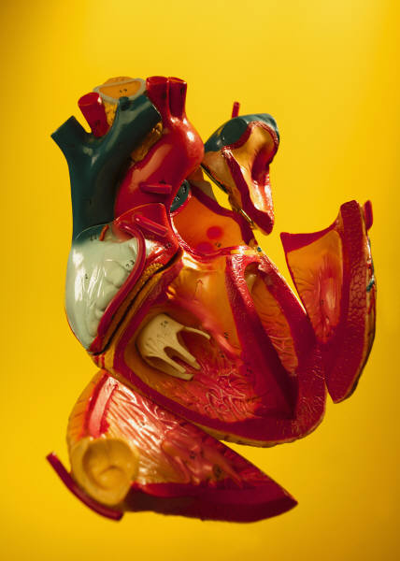

First of all they showed us a diagram of how our blood vessels (veins and arteries) travel around our bodies. They showed us where the vessels went and how far they travel. To make things more simple they selected a couple of children to wear a sign saying either “Left Side of the Heart” or “Right Side of the Heart”. More of the signs said “Foot” and “lungs”.

The heart dissection allowed us to feel and see the parts of a human body. Personally I felt sick looking at the heart. We thought it was amazing we could feel a replica of the human heart.

By Saul Clarke and Fraser Heanue

YEAR 6

Year 6 has certainly been a productive classroom over the past few weeks. The children have been working extremely hard in all of their lessons in order to ‘show off’ their skills in the forthcoming assessments.

In literacy we have been focussing upon our writing skills following out fantastic results in our reading assessments. Consequently we have focussed upon a new genre of writing each week. Our class have now mastered the skills of persuasion and can write a very forceful letter.

For our curricular target in Numeracy we have completed lots of tasks focussing on shape. The use of technical vocabulary has been a high priority in our description of 2D shapes.

Gymnastics has been our focus for our games lessons throughout the term. We have had a lot of fun using the equipment and exploring the different shapes and movements we can create.

The Year 6 children should be commended on the effort they are applying both in school and at home. I think a big “thank you” should also be extended to all the parents and family members who are supporting the children at home. - Not long now!

LETS HEAR IT FOR THE BOYS

A leaflet is attached with your newsletter on how parents can make a difference with their son(s) attainment in school.

EASTER HOLIDAYS

A reminder that school will close for the Easter Holidays at 3.30 p.m. on Friday, 30th March, 2007 and will re-open for the summer term on Monday 16th April at 8.45 am for readers and at 8.55 am for registration.

