SHOBNALL PRIMARY SCHOOL

SUMMER NEWSLETTER

Dear Parents, JULY 2006

We have pleasure in enclosing the Summer Newsletter, which brings you the latest information and the range of activities, which have been happening at Shobnall Primary School in the last few weeks.
__________________________________________________________________________

WELCOME TO FOUNDATION STAGE AT SHOBNALL SCHOOL

On Thursday 8th June Mrs Roobottom welcomed new and existing parents of children who will be joining the Reception class in September. The parents were informed about the organisation and running of the school from members of the school staff. Parents were given opportunities to view the whole school and then were shown the Reception classroom where they were able to meet their child’s teacher, Mrs Bickley. Mrs Roobottom and the staff were very pleased to meet the large number of parents who attended the meeting. Thanks go to Mrs Roberts who supervised a crèche for children during the meeting.

Following the meeting the new Reception children have had opportunity to visit school on two afternoons – 13th June and 4th July – in order to become familiar with both the school environment and the teaching staff. Mrs Bickley is hoping to meet the children again this term at either at home or at the children’s existing pre-school establishment, as part of the school’s commitment to providing home-school liaison for ‘Parents in Partnership’.

On Wednesday 14th Mrs Roobottom welcomed new and existing parents of children who will be joining the Nursery in September. During the meeting the parents received information about the organisation of school; were given a tour of the infant building; were given a demonstration of the information technology support used in school; viewed a video explaining the nature of the curriculum specific to children from 3 to 5 years and of course met their children’s teacher, Mrs Short, in the Nursery environment. The children have had opportunities to spend time in the Nursery with Mrs Short in preparation for their admission in September.

Mrs Roobottom and the staff were very pleased to meet the parents which for many of the children will be the first year of eight years at Shobnall. Thanks again go to Mrs Roberts for providing a crèche.

This term has proved to be busy and eventful with topics on ‘Healthy Living; ‘Summer’ and ‘Holidays’. We kicked off with a visit to Brykley Park Garden Centre with Reception which proved both enjoyable and productive. It was a brilliant morning, we learnt about plants and shrubs, visited the animal corner and finally we carefully planted a Busy Lizzie to take home. Special thanks to those mums that accompanied us there, Ms Burn, Ms Calder, Mrs Reid, Mrs Smith. We have continued the tadpole watch, the transformation from tadpole to a tiny froglet has been amazing. Mrs Curran will return them to her pond. The Shobnall Swallows have also proved to be a fascinating watch. We have eagerly followed their progress from egg to fluffy chick to feathered fledgling.

Sports Day proved popular and exciting for us. We rose to the challenge and the children were put into their school teams. We were extremely proud of the children’s performance. Well done children.

We will be finishing with a picnic in the park – on the school field – which the children will prepare!

Mrs Curran, Mrs Marston and I would like to thank all the parents for their continued support, co-operation and kindness, without which ‘nursery school’ would not be so enjoyable and productive. Without exception all the children have progressed well in their school work and are ready for their next school step into Reception. We wish them well.

We wish you all a very happy and safe holiday.

RECEPTION

What a busy half term we have all had in reception. The children have particularly enjoyed Sports day, World Cup day and the Year 6 Fair.

SUMMER AND HOLIDAYS

Our topics this term have been holidays and summer, which the children have been very excited about. We have developed our role play activities through airport and shop home corners. The children have been extremely creative making boats, sun glasses and beach mats using a variety of skills successfully.

They have participated in whole class numeracy and literacy lessons to develop their independence and transition into Year 1.

I have been particularly impressed with the children’s number work and development of their curricular target: Fractions.

Well done Reception, enjoy your well deserved rest ……

New Key Stage 2 parents meeting

This meeting provided parents with pupils who are currently in year 2 to meet the KS2 teachers and to ask questions about the changes to the curriculum, new requirements and anything else they wished to raise.

The meeting highlighted the changes in timetables and also any new subjects which are delivered with key stage 2, notably French! Parents also had the opportunity to tour the Key stage 2 classrooms and look at the standard of work being produced by our pupils further up the school.

The attendance was fantastic yet again and thanks must go to those who yet again showed their support for the school.

YEAR 3

Year 3 have had a very busy and enjoyable term. We all thoroughly enjoyed our school trip to Snibston Discovery Park especially the Colliery Tour and water experiments! We have also been busy designing and making our own sandwiches for a class picnic and came up with some interesting concoctions. We also had a brilliant time on our Roman Day and especially enjoyed dressing up and making shields.

A super term Year 3 you have all worked very hard and I hope you have a lovely holiday.

New admissions to School

Shobnall Primary School would like to welcome the following children who have joined us this term:

Niamh Mellor – Year 1
Tyrone Burton – Year 4

It seems amazing to think that the children in Year 4 have completed their time and are now ready to move to Miss Jones. It only seems like last term that they all arrived, looking apprehensive although eager.

It certainly has been a very busy year, thinking back to the study of the Tudors and our Tudor day, all the way through to our fantastic trip to Cadbury World – We all thoroughly enjoyed the trip!

Mr Cruise has also enjoyed this year and we know that the children have, more often than not. It is great to see that so many of the pupils have continued to read at home throughout the year and also continued to practice their tables. It is amazing to see the confidence of so many children now with their numeracy, possibly because they have finally learnt their tables!

‘Table tables’ has been fun throughout and we must thank all parents for their continued support and help, we know that one parent was horrified to be asked to test their son’s table’s knowledge whilst sitting on a pedalo out in the Mediterranean! We have had many different champions in the Premiership, Bethany Taylor, Luke Dennis, Alma’s Rafigue and Lewis Rumin. They have all been pushed hard in their victories and we know that many pupils have just missed out claiming the title.

The children all produced wonderful Aztec projects this term and it is amazing to see the time, energy and effort put in by all children. They produced a vast array of work, ranging from project folders, to death masks, to Aztec jewellery. Thanks to all parents and pupils for your time.

Mr Cruise states “I have certainly enjoyed teaching Year 4 this year and I will be sad to see them move on although I am looking forward to teaching my new class next year. Maybe I will have more luck in converting these new children into supporting the mighty Sheffield United; I definitely failed with this year’s crop although I thought one or two were nearly with me!”

Thank you once again for all your support, with regards to homework, spellings, reading and tables. Without parents involvement, the children would not have had such a successful year, please continue your involvement in year 5, it really is greatly appreciated by all teachers. Thank you.

YEAR 5

Year 5 have an extremely busy last half term. The children have been working very hard to complete their topics which they have all enjoyed. Well done to Year 5 for all their efforts and determination to do well. We hope you are all looking forward to Year 6 where I we are sure you will all achieve your best.



PAGET TRIP

On Monday 26th June 2006, Year 5 had the opportunity to visit Paget High School to gain an idea of what Secondary School is like.

They were able to meet some teachers and take part in two lessons before returning back to school.

The children particularly enjoyed the business lesson where they were put into groups and had to produce an end product. The most successful team won a box of chocolates, which they kindly shared with the class.

When back at school, the children said they had enjoyed the morning and are looking forward to visiting a secondary school again.

The Science Play

I really enjoyed the play. My favourite part was when one the characters changed the verse. I think everyone enjoyed it because everyone took part in the questions. I also liked the karate part; I really hope they come again.

Jaden Foster, Year 5

The Science Production

On Wednesday 28th June 2006 we had the Quantum Theatre come to our school to perform a science play for us. The play was about walking to school, and how it helps top pollute the air.

This play had a song in it which was very catchy. The song was very good but at the same time educational. At the end of the play they got us all standing up and dancing to the song. They taught us that driving to school pollutes the air with the fumes that the car makes and produces. It was funny because they made it an interactive production by asking us questions and making us put our hands and arms in different shapes for different answers to questions. The person or thing who asked us the questions was a so called ALIEN.

This was just a summary of the play. Everyone really enjoyed it and was well worth the time spent on it. The teachers really enjoyed it too.

By Jodie Allen and Sian Plummer. Year 5

The Science Theatre

On the 28th June a Science Theatre visited our school. The Science Theatre was all about walking to school. In the theatre there were songs to really interest the school especially the Year 3’s. In the show it was like a computer game, because, there was an alien that asked us questions like “in 40 years how much would the sea level rise?” – The answer was either a) 3 cm b) 10 cm or c) 21 cm. The correct answer was c) 21cm. If you got it correct you would move on to the next level.

They taught us about how pollution can affect the environment by driving a car and nuclear power plants sending off bad gasses into the sky. I think everybody enjoyed it and learnt a good lesson to walk to school instead of driving. It was great fun to have the science theatre in Shobnall School.

By Oliver Arnoux - Year 5

WORLD CUP DAY

On Friday 7th July Year 6 took part in a world cup day, the class were involved in a variety of activities which included, trying German foods, making posters about Germany, speaking the German language and playing football all atternoon. After every game had been played the winner of the boys contest was Year 6 and the winners of the girl contest was a joint win between Year 5 and Year 6. It was a great day!

YEAR 6 FAIR

Our Year 6 Fair proved to be a great success. The Year 6 class decided on the stalls they would like to run and organized the products that were brought into school. Each group designed their own posters and set the prices for their stalls.

The fair was a massive success and was thoroughly enjoyed by all. The children raised £300.00.
- £50.00 will be donated to the British Heart Foundation
- £50.00 will be donated to Cancer Research
- The remaining money will be used to purchase new books for the library and plants for the garden.

We were certainly fortunate with the weather this year for the event, as last year we had to cancel this athletics meeting. The school entered children from years 4, 5 and 6 into a variety of different events and we experienced a number of notable successes.

It was a great opportunity for many children to yet again represent the school and as for the Year 6 pupils, the last chance they will have of representing Shobnall Primary school.

The children competed in many activities from obstacle courses, potato races and of course, the old favourite – the sack race, Tyrone Burton in year 4 proving he is the 3rd best in the Dove Valley!

The children all thoroughly enjoyed the evening as did many parents who stayed to support the pupils and many children have already asked if we will be entering again next year. This event is open to pupils in years 4, 5 and 6 so hopefully the current Year 3’s are already practicing and ready to bring more sporting success to Shobnall Primary.

FRIENDS OF SHOBNALL PRIMARY SCHOOL

We have just completed our first year of fundraising with various different events. A huge thank you for all the support from people attending the meetings and also for all the people which offer their help to make these events happen.

Over the past year the following fundraising activities have taken place and have been a great success.

Christmas Fayre £956.17
School Disco £267.38
Choir Concert Raffle £61.00
Sport Day Raffle £61.00
Summer Fayre approx £900.00

Club 100

This was started in April and each month has raised £50 for the school and £50 for prizes. The last draw to take place is exceptionally exciting as the prizes are doubled. If you require an additional number for the draw please see Sam or Rachel with your money.

The winners for May were:

1st £30.00 Joanne Coombs
2nd £15.00 Rachel Craven
3rd £5.00 Helen Foster

And for June were:

1st £30.00 Julie Dalzell
2nd £15.00 Scott Carpenter
3rd £5.00 Jackie Phipp

SUMMER FAYRE

What a fantastic day for everybody including children, parents, teachers, grandparents. The weather was excellent, lots of stalls to keep you amused and what superb talent was displayed from the finalists. This was our first Summer Fayre and we would welcome comments to help next years become even more successful. If you could write your comments down and drop them into the suggestion box in reception, it would help us to organize next year’s event.

SPORTS MORNING
We were very lucky with the weather for our second sports morning and a good time was had by all.

The children all had a fantastic time and became fully involved in the events of the day. We would like to commend the children in the effort they applied and the superb behaviour they demonstrated on the day.

We would like to extend my thanks to all parents who offered their help on Sports Morning and the extra helpers who offered on the day. It is wonderful to know we have such great support from our parents.

A total of £51.50 was raised from the sale of cakes and refreshments on the day.

TALENT SHOW

The children thoroughly enjoyed the Summer Talent show and the quality of the performances of all the children involved was reflected at the Summer Fayre. Congratulations to
Thomas Gregory in Year 1 who won the contest with his excellent poetry reading and to Dana Page who came a close second. We hope that all children who entered the show but didn’t make the finals will be given the chance to perform their acts in front of the whole school during the last week of term.

ROUNDERS

The children worked hard in rounders club and demonstrated some excellent catching, throwing and batting skills. The rounders team took part in a tournament at Richard Wakefield School on Tuesday, 27th June, 2006 and although they didn’t win all members played very well with some super bowling by Aaron Tyler.

FROM THE KITCHEN

September 2006 sees new changes at break times and meal times.

Due to new nutritional guidelines that will be introduced September 2006 we will only be allowed to serve water or semi-skimmed milk (⅓ pint cartons). Water will be available at the table for lunch and milk cartons will be offered as well.

The good news: “there is no price rise”. Meals will therefore remain at £1.65 per day or £8.25 per week.

CRICKET

Well done to all the children who attended the Cricket Coaching course at Burton Cricket Club. The children learned new skills and new tactics, from the cricket coach Mr North, who is also our School Governor. The end of the season culminated in a mini cricket tournament at the club, where all children had the opportunity to test out their newly acquired skills. Our grateful thanks to Mr North for giving children the opportunity to play at such a prestigious club and “INSPACE” who sponsored the children, all tournament participants received a cricket cap and water bottle from the Managing Director of Inspace.

YEAR SIX VISIT TO THE

AMERICAN ADVENTURE

On Friday 14th July Year 6 visited the American Adventure Theme Park on their final trip at Shobnall Primary School. We were rewarded with fantastic weather and an empty theme park! Everybody had a wonderful time and took full advantage of the variety of rides available to us. We could hardly keep the teachers off the roller coasters!

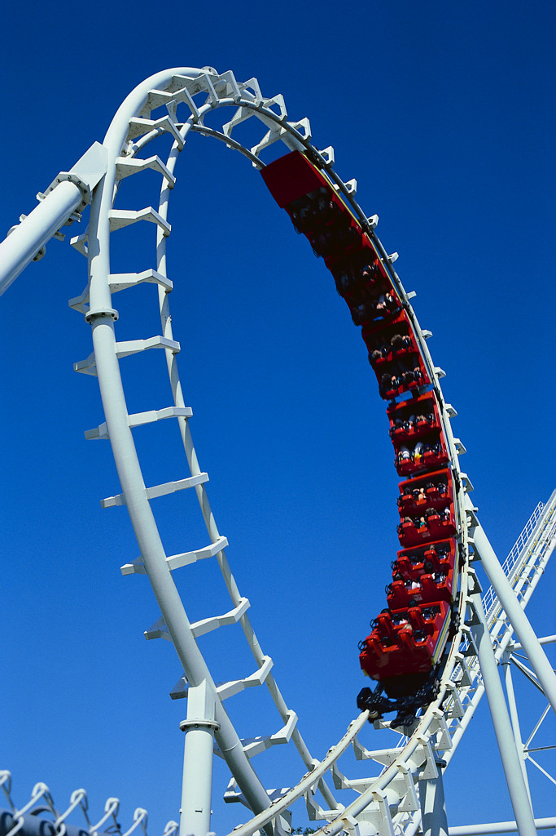

We would like to say a big ‘thank you’ to all the staff that helped on the trip ensuring all the children had a fun and safe experience.

This was an amazing experience that we will all remember and treasure in years to come.

World Cup Day

The whole school enjoyed an action packed day to enrich geography across the school, from dressing up to football competitions.

Nursery-England
Activities and making hats
Reception - Italy
Pizza race, designing pizza/football strip, pasta necklaces, making hats and eating pizza
Year 1 - France
Language booklets/food tasting
Year 2 - Italy Booklets, art
Year 3 - Argentina Posters, activities
Year 4 - Brazil
Football comp, food tasting
Year 5 - Portugal
Football comp, food tasting
Year 6 - Germany
Football comp, food tasting

DAYS OF DICKENS

On Tuesday 18th July the junior classes watched a ‘Days of Dickens’ production. This was a great opportunity for the children to learn about the life and times of Charles Dickens and gain an introduction to some of his stories.
Good news
Mr & Mrs Burton are pleased to announce the safe arrival of baby Sophie on Friday 30th June 2006, weight 6 lbs 13 oz.
Congratulations from everyone at Shobnall School

SUMMER HOLIDAY

School closes for the Holidays on Friday 21ST July 2006 at 3.30pm and re-opens on Tuesday 5th September 2006 at 8.45 for readers and 8.55 for registration.

